**RESEARCH PAPER**

**TITLE:**

**FOREST** **FIRE** **PREDICTION** **USING** **WSN** **AND CO2 SENSORS**



Branch: computer science and engineering

College name: VITAP

State: Andra Pradesh

Country: India

Guided by :Sibi chakravarthy



→Wildfires are one of the biggest catastrophes faced by our society today causing irrevocable damages.

→These forest fires can be man-made or caused by mother nature by different weather conditions, torrential winds.

→These fires cause damages not only to the environment they also destroy vast homes and property.

INTRODUCTION →Hence we devised a panacea "Forest Fire Prediction System" to fight this disaster and help our planet.

→Wildfires monitoring can be more effective when combined with Artificial Intelligence technologies (AI) and Data Analytics.

→Many recent AI technologies and data science technologies have been widely applied for developing new wildfires prediction systems.



• Fire may take place in various places and may be caused by different mechanisms. Its humanitarian, economical and environmental catastrophic effects vary depend- ing on its type (causing factor), location, scale, etc. Despite all the precautions, the US National Interagency Fire Center reports occurrence of 15,918 fires affect- ing 403,509 acres in 2009 alone [15]. Fast and effective fire detection is the key in fighting the fire. To this end, over the years various technologies and detection mechanisms have been developed and used not only to speed up the detection pro- cess but also to enhance reliability of the information analysis. The fact that fire is basically the fast oxidation of a substance that produces gases and chemical pro- ductions makes high spatial and temporal resolution sensing technologies such as wireless sensor networks (WSNs) a better candidate for fast fire detection compared to often-used low spatial and temporal resolution remote sensing and satellite imagery

devices equipped with radio, memory, processing units as well as different type of sensors (e.g., temperature, humidity, smoke) being densely deployed in an environment to monitor a phenomenon.

A careful analysis of existing research in the field of fire detection reveals that while much attention has been paid to developing complex detection algorithms, not equal attention has been paid to analysis of fire data to identify the most effective features and the optimal set of features (sensors). In this paper, by applying data analysis and feature extraction techniques originated from computational intelligent field on two fire data sets, i.e., wildfire and residential fire, we identify the most con-tributing features (sensors) to the process of

 ~~fire detection [1, 2]. We then apply our~~

distributed naive Bayes and neural network

outlier detection techniques designed for



ABSTRACT

→ Wildfires are an uncontrollable disaster which cause damages to the society as well as endanger the nature.

→ Forest Fire Analysis and Prediction System is built to detect the forest fires and then performs prediction of the fire spread.

→With the help of big data analysis and machine learning algorithms we intend to build a tool which serves an aid to the society and thus prevent the occurrences of this disaster.

→The method used in this project combines Big Data, Remote Sensing and Data Mining algorithms to process data collected from satellite images over large areas and extract insights from them to predict the occurrence of wildfires and avoid such disasters.

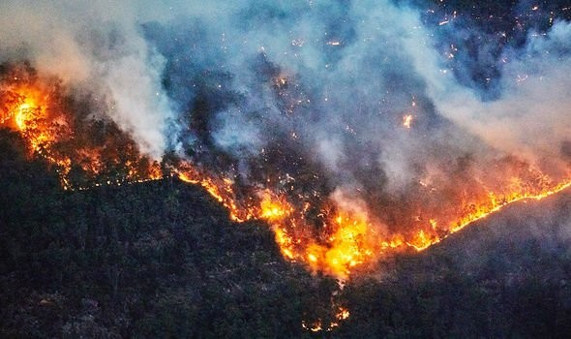

|  |  |  |
| --- | --- | --- |
|  | So as we seen that many lives were lost in **in** **us** |  |
| **By** **building** **a** **model** **with** **the** **help** **of** **a** **dataset** **with** **more** **accuracy** **will** **help** **many** **countries** **to** **prevent** **fires** **from** **happening.**  **So** **we** **have** **taken** **the** **project** **forest** **fire** **predictions** **with** **the** **dataset** **having** **temp,** **rains,** **winds** **and** **e.t.c** **as** **the** **factors** **.** **With** **the** **factors** **we** **are** **going** **to** **train** **and** **build** **a** **model** **which** **may** **give** **more** **accuracy** **based** **on** **different** **algorithms.** |
|  |  | |

SYSTEM ARCHITECTURE

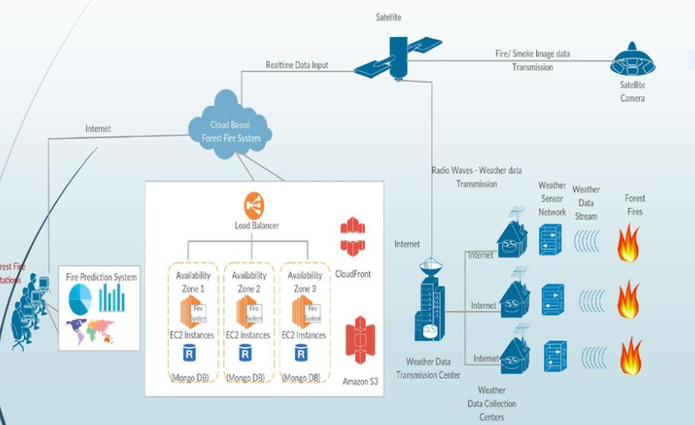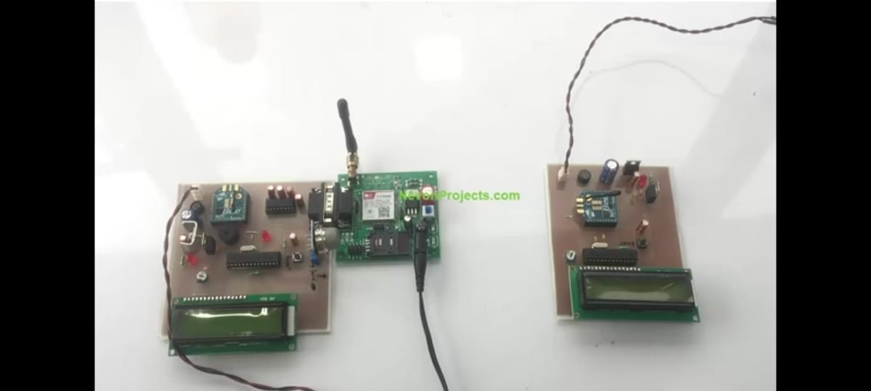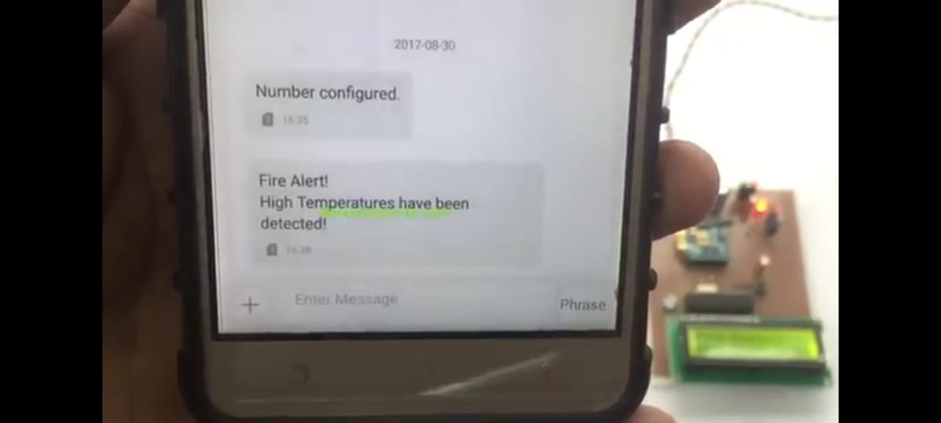

**Basic** **Model:**



DIFFERENT MODELS USED

Our basic model just uses a *linear* *model* with all 12 predictor variables to account for area burned.

However we can see that **month,** **DMC** are a significant predictor.

**Second** **Model:** **Add** **interactive:**

We saw in the correlation matrix that there was a large correlation between the forest fire index variables (FFMC,DMC,DC and ISI). It may therefore be beneficial to look at interactive terms between these variables. The same may also be said for the weather variable which also show some correlations.

We can also see the following predictors are now significant: **month,** **DMC,** **FFMC.DMC**



NEW PREDICTIONS

The model can now be used to predict forest fires based on new predictor values. As we ask the user to input these values to the console command line

before returning the predicted value.

FOREST FIRE DETECTION

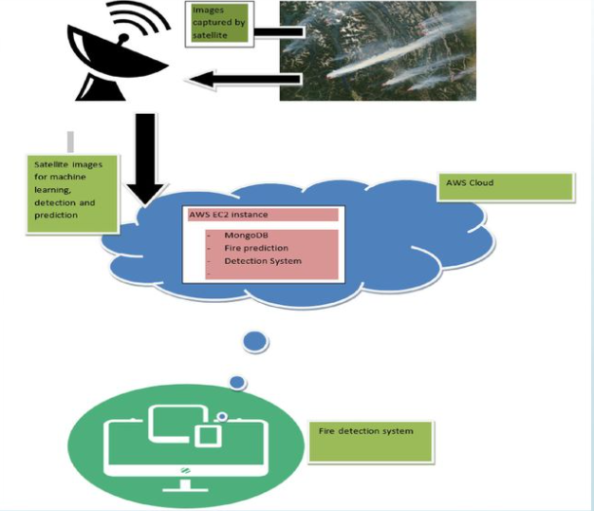

As an upgrade to the system, researchers at ICIMOD recently incorporated data from the Visible Infrared Imaging Radiometer Suite (VIIRS) – a sensor on NASA’s Suomi satellite – to complement the MODIS data. The result is both enhanced spatial resolution over fires of relatively small areas and improved mapping of large fire perimeters. A mobile application – usa Forest Fire Detection and Alert – was deployed to support citizen reporting on fire incidences in usa and the system has already been helpful in planning and allocating resources for forest fire management. Through the use of this application, members of forest community groups can now respond more quickly to fire dangers and Department of

 Forest officials can better understand forest

fire patterns to help inform future management strategies.

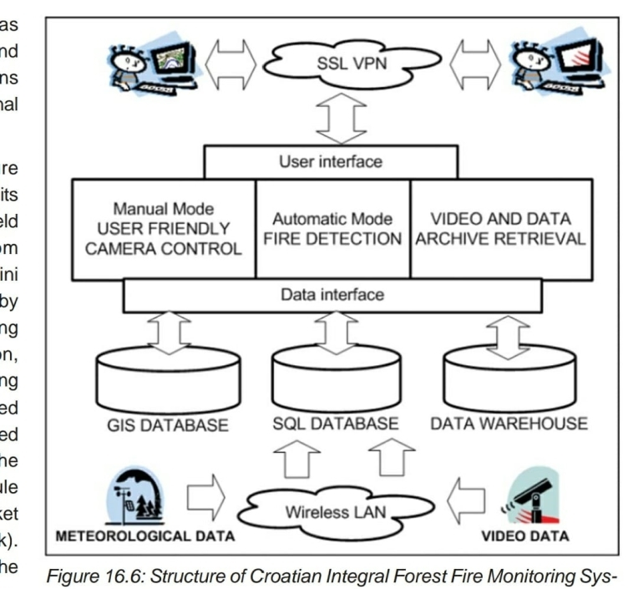

<https://www.manxtechgroup.com/forest-fire-detection-using-iot-and-co2-sensors/>

CO2 and temperature IoT sensors are battery and solar-powered, using a combination of LoRaWAN and satellite communications to provide coverage even in remote areas.

A LoRaWAN gateway can provide network coverage for up to 15KM outdoors, while satellite backhaul



ensures traffic can be sent back to your monitoring

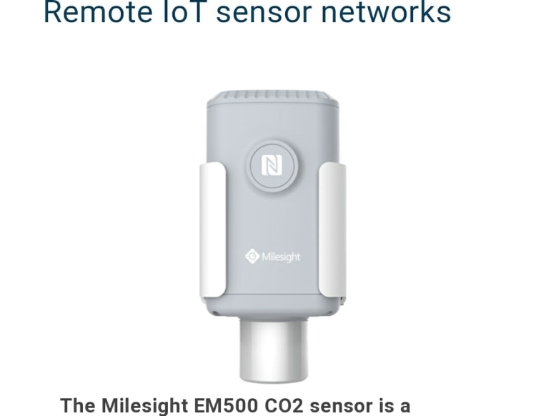

RESULT

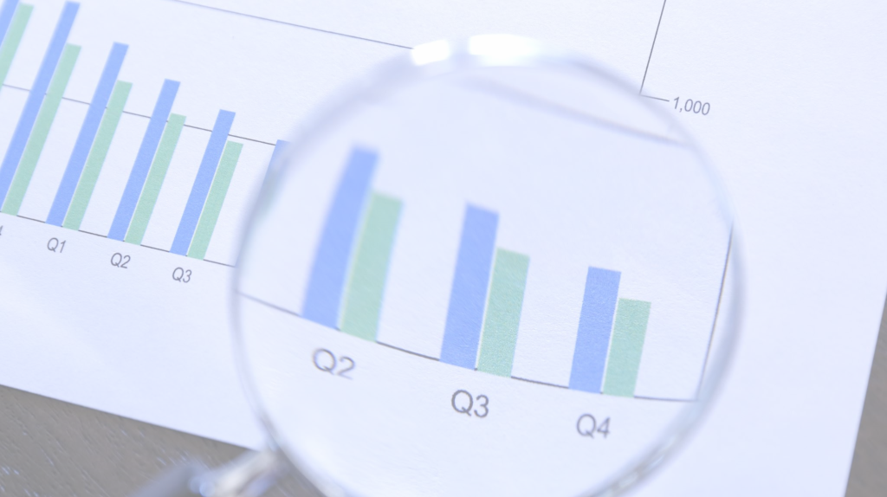

AND ANALYSIS

CONCLUSION



→The objective of this is to reduce the damage and destruction that are caused by the forest fire to the life and property of humans and also wild animals

→Through this project developed a tool to help mitigate and prevent the losses seen due to forest fires.

→Innovative solution which detects the forest fires and then performs the prediction based on the prevalent conditions.

→Learnt to build a hybrid model using big data analysis

→We have also attempted to predict the fire in advance with the help of the data obtained that are deployed in the forest.

→Integrate live satellite data and process real time processing of the fires.



FUTURE SCOPE

→Enhance the time complexity of the detection. of fires to improve the speed.



|  |  |
| --- | --- |
| THANK |  |
| YOU SIR |  |
|  |  |

